Overview and Acknowledgments:

The PCI Sound Pro is a new generation PCI stereo 16 bit PnP sound card. It used CRL® technology HRTF 3D positional audio and supports Microsoft® Direct Sound ® 3D and Aureal®’s A3D® interface, support two / four speakers, DLS based (Down Loadable Sound) wave table music synthesizer which supports the Direct Music®. Legacy audio SB16® compatible and professional SPDIF IN/OUT clearest non-distortion digital interface, it also supports MPU-401 interface, dual game ports… What we provide at the side of the sound card are line-in jack, microphone jack, audio output jack, SPDIF/OUT jack and 15pin D-SUB multiplexed joystick/MIDI connector.

Trademark Acknowledgments

Microsoft are registered trademarks, and Windows, Direct Sound 3D and Direct Music are trademarks of Microsoft Corporation. Sound Blaster is a trademark of Creative Technology, Ltd. Aureal is a trademark of Aureal Inc. A3D is a registered trademark of Aureal Inc. All other trademarks and registered trademarks mentioned in this manual are the property of their respective holders and are hereby acknowledged.

Information in this manual is subject to change without notice.

FCC Compliance Statement

Certified to comply with the limits for a Class B computing device according to Subpart J or Part 15 of FCC rules.

Product Features:

• Special Features
PCI Plug and Play (PnP) bus interface, 32 bit PCI bus master.
Full duplex playback and recording, built in 16 bits CODEC.
HRTF 3D positional audio, supports both Direct Sound 3D® & A3D® interface, supports earphone, two and four chennel speakers mode.
Support Windows 3.1 / 95 / 98 and Windows NT 4.0.
Built-in 32 OHM Earphone buffer and 3D surround.
MPU-401 Game/Midi port and legacy audio SB16 support.
Downloadable Wave Table Synthesizer, support Direct Music®.

• Digitized Audio (SPDIF IN/OUT)
Up to 24 bit stereo 44KHz sampling rate voice playback/recording.
Full duplex playback and recording, 120db audio quality measured.
Auto detectable SPDIF/IN signal level from 0.5V to 5V.

• Stereo Mixer and FM Music Synthesizer
Stereo analog mixing from CD-Audio, Line-in
Stereo digital mixing from Voice, FM/Wave-table, Digital CD-Audio
Mono mixing from MIC and software adjustable volume
OPL3 FM synthesizer (4 operators)
Up to 15 melody sounds and 5 rhythm sounds (20 voices)

• Game and Midi Interface
Fully compatible MPU-401 Midi UART and Sound Blaster Midi mode
Standard IBM PC joystick/game port (dual channel)


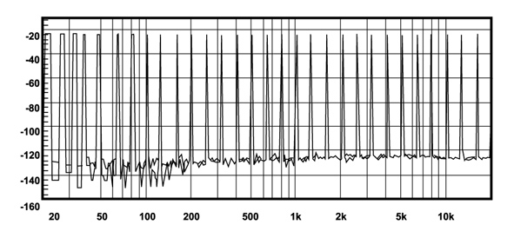
120db audio quality in both playback, recording and bypass modes.

Connectors and Jumper setting informations
Connector | Function
J1 | SPDIF/OUT signal level: ( Open: 0.5V, Short: 5V )
J4 | SPDIF/IN Port ( 5V/0.5V signal auto detectable )
J2 | AUX_IN Port ( Signals: L – G – G – R )
J3 | Analog CD/IN Port ( Signals: L – G – G – R )
J5 | Analog CD/IN Port ( Signals: G – R – G – L )
J6 | PC Speaker_IN Port
LINE_IN/REAR | (LINE_IN) Connect with the audio output port of stereo  (REAR) Connect to the rear speakers while four chennel speakers mode enabled, used as AUX LINE_OUT
MIC | Connect with the Microphone ( Mono )
LINE_OUT | Output to the speaker or Audio_IN of stereo
SPDIF_OUT | Connect with Mini Disk, LD Player or AC3 Amplifier
GAME/MIDI | Connect with Joystick or devices that use MIDI interface
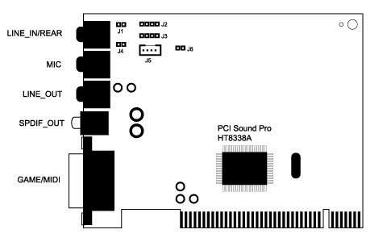

Installation of DOS and Windows 3.1

Please make sure that your hard disk has 4MB free spaces at least. Insert the Driver CD into the CD-ROM Drive.
1. Change to drive D( same as the CD-ROM drive ) at DOS prompt, type in
INSTALL [Enter]
2. Type DOS utilities path that you want to install.
3. Type the path of Windows 3.1 when asking Windows path.
4. Program will expand file to path that you specify.
5. After expanding DOS utilities, program CMINIT.EXE will be executed and showing current value of all I/O. Please adjust I/O to avoiding conflict, if you were in non-PnP mode. Press ESC key to exit.
6. Mixer program CMMIX.COM will be executed too. You can adjust default volume to your favorite value. Press ESC key to exit.
7. Install program will continue execute testing program CMTEST.EXE to check output of sound card.
8. Program will launch Windows 3.1 to install device drivers and applications.
9. Please restart PC after installation completed.

Installation of Windows 95 / 98

We recommend that you have already installed Microsoft Windows before you installing PCI Sound Pro card, and you didn’t install any other sound card device drivers in your current system.
1. Power off your system, install PCI Sound Pro sound card, audio cable, speaker, microphone, and insert driver CD into the CD-ROM drive.
2. Turn on the computer, and enter into Microsoft Windows 95 / 98.
3. You will see a windows prompt like this:
“New Hardware Found
CMI8338 Audio Adapter ( PCI Multimedia Audio Device )
Windows has found new hardware and is installing the software for it”, then the dialog box shown.
4. Select “Driver form disk provided by hardware manufacturer”, click “OK”.
- When system requests for CMI8338 PCI Sound Pro’s installation disk. Please make sure the drive and path is point to place that installation driver is in, and click “OK”.
- Now, system is installing device drivers automatically. After a while, system finished installation, which will included the following device drivers.
C-Media SoftMidi Drivers
CMI8338/C3DX PCI Audio Device
CMI8338/C3DX PCI Audio Joystick Device
CMI8338/C3DX PCI Audio Legacy Device
8. Click “start” key
9. Select “Run”
10. Key in the drive and path for Windows applications install program, such as “D:\W95AP\SETUP.EXE”
12. Click “OK” to start the procedure of installation, and follow questions to finish installation, shut down Windows 95 / 98 system and reboot your system, when all of application softwares have been installed.

Installation of Windows NT 4.0

We recommend that you have already installed Windows NT 4.O before installing PCI Sound Pro card. And you didn‘t install any other sound card device drivers in your current system.
1. Click “Start” button, move highlight bar to “Setting” item, and select the “Control Panel”.
2. Double click “Multimedia” icon.
3. Select “Devices” page and press “Add” button.
4. Select “Unlisted or Updated Driver” item in “List of Drivers”.
5. Specify drive and path that NT drivers is in (such as D:\NT).
6. Select “C-Media CM8338” item and press “OK” button.
7. Select proper value of I/O.
8. Press “OK” button.
9. Restart system when asking.
- Now, you have already installed CMI8338 PCI Sound Pro card on Microsoft Windows NT 4.0 successfully. if you want to install the Windows applications, continue the following steps:

- Click “start” key.

12. Select “Run” item.
- Key in drive and path for Windows NT applications install program, such as “D:\NTAP\SETUP.EXE”
- Click “OK” to start the procedure of installation, and follow questions to finish installation, shut down the Windows NT system and reboot your system, when all of application softwares have been installed.

Windows Appc. (PCI Sound Pro Rack)

Introduction
PCI Sound Pro Audio Rack gives you control over your PC’s audio functions through a user interface as simple to use as a home stereo system, included the advantage of four speakers mode enable / disable, perfect digital sound ( SPDIF ) input / output control.

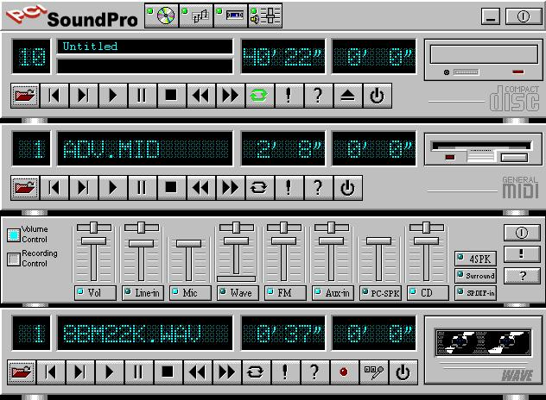
Audio Rack of PCI Sound Pro

Audio Rack consists of several major components:
Control Center: Controls the display of PCI Sound Pro Audio Rack’s compoments.


MIDI Player: Plays MIDI music files. Lets you create song playlists and play the song files.
Wave Player: Records and plays digital audio (wave) files. Lets you create wave file playlists and playback the wave files.
CD Player: Plays standard audio CDs. Allows you to create playlist collections of CD tracks (songs).
System Mixer: Sets the volume level of your audio inputs and outputs.
Showing or Hiding Audio Rack Components
To remove or add a component from display, click on the component's button on the Control Center’s Button Bar or toggle it off.

MIDI Player, Wave Player, and CD Player
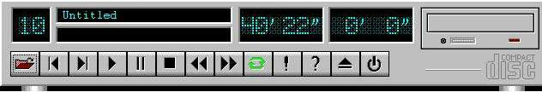
CD Player (above, similar to Wave Player and MIDI Player)
Sel (or Trk) field: If you have multiple selections in your playlist, this shows the number of the current selection or CD track.
Current File or Track: The name of the current MIDI file, wave audio file, or CD track.
Total Length field: displays the total length of files or tracks in minutes and seconds.

Current Time field: displays the current time of files or tracks in minutes and seconds when playback or recording.

Please refer to help screen for more detail button functions description. (click on help “?” button on player)

System Mixer
System Mixer lets you control all audio output and input levels.

System Mixer displays the volume controls that your audio drivers make available. The names for these controls may vary.

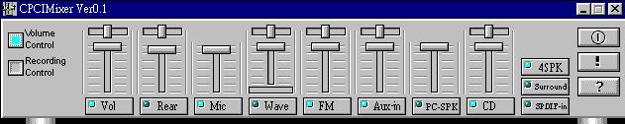
Mixer panel while four speakers mode enabled.
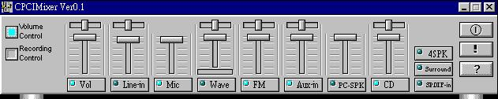
Mixer panel while four speakers mode disabled.
Volume Control: Clicking on this button shows and lets you use the output level controls.
Recording Control: Clicking on this button shows and lets you use the input level controls.
Input and Output Level Sliders and Buttons: For each input or output signal type, a control slider controls the loudness, a horizontal slider controls balance between the two speakers, and the mute button temporarily stops input or output without changing slider positions.

Control types and names vary. Some common types are listed below:
- Vol: The master control for all outputs. The strength of an output signal is determined by both the Vol slider and the slider for the individual output. To affect all outputs, move the Vol slider. To change the output of an individual output type, move its slider.
- Line-in/Rear: Controls the audio hardware's Line In or Line Out levels. Line levels might be for an externally attached cassette player, e.g. While the four speakers mode enabled, this control becomes the Rear speaker volume control.
- Mic: Controls the microphone input level.
- Wave: Controls wave (voice) playback or record levels.
- FM: Controls the FM music play or record level.
- Aux-in: Controls the Aux-in music play or record level.
- PC-SPK: Controls the external PC speaker input level.
- CD: Controls the CD drive output level, for CD drives configured to play their audio output through the PC’s audio hardware.

- 4SPK: Turn on or off the Rear speakers effect.
- Surround: Turn on or off the 3D surround sound effect.
- SPDIF-in: Turn on or off the SPDIF digital signal input.

Mute Buttons: Toggle between muting and enabling the signal. A button with a lit LED is enabled, while one with its LED not lit is muted. Several output signals can usually be enabled at once.

Diagrams for four channel speakers applications:
